# Overview

The Imtech NavVision BNWAS Is a standalone, type approved BNWAS system that can be used on all vessels that need a mandatory BNWAS. Its basic setup consists of the following parts:

* Beijer Exter T70-bl
* Wago I/O system 750

Additionally the following parts are provided:

* Phoenix Contact FL switch SFNT series
* Watch Alarm Panel 1st, 2nd and 3rd stage
* Reset Buttons

Schematically it will look as shown in Figure 1‑1

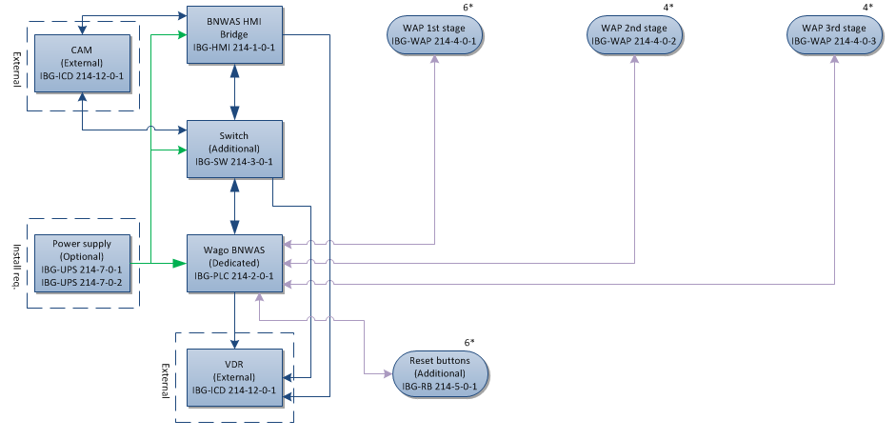

Figure 1‑1: BNWAS standard setup

*: The serials in the figure, like IGB-XXX 214-x-x-x refers to the specified manuals on that item that can be found on sharepoint.*

This standalone system can also be integrated in the Imtech Unimacs bridge, or in the NavVision AM(C)S system. In that case a few extra items will be added to the standard topology. This can be an addition to the standard topology, but it can also replace items in the standard setup. Reset buttons can be made obsolete because there is a screen with a reset button on the AM(C)S at every control position and EVE-messages can be used to comfirm the ability of the OOW, also WAP panels can be redundant because there are already DAP’s in the 2nd and 3rd stage cabins.

Schematically it will look as shown in Figure 1‑2

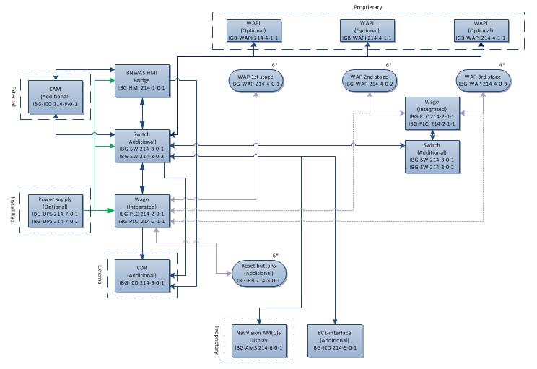

Figure 1‑2: BNWAS integrated setup

## Layout of the manual

This manual will incorporate three different stages of the mandatory manuals. It will be divided into the following subsections:

* Installation manual
* User manual
* Maintenance manual